PREPARATION PHASE WORKING WITH THE DATASET

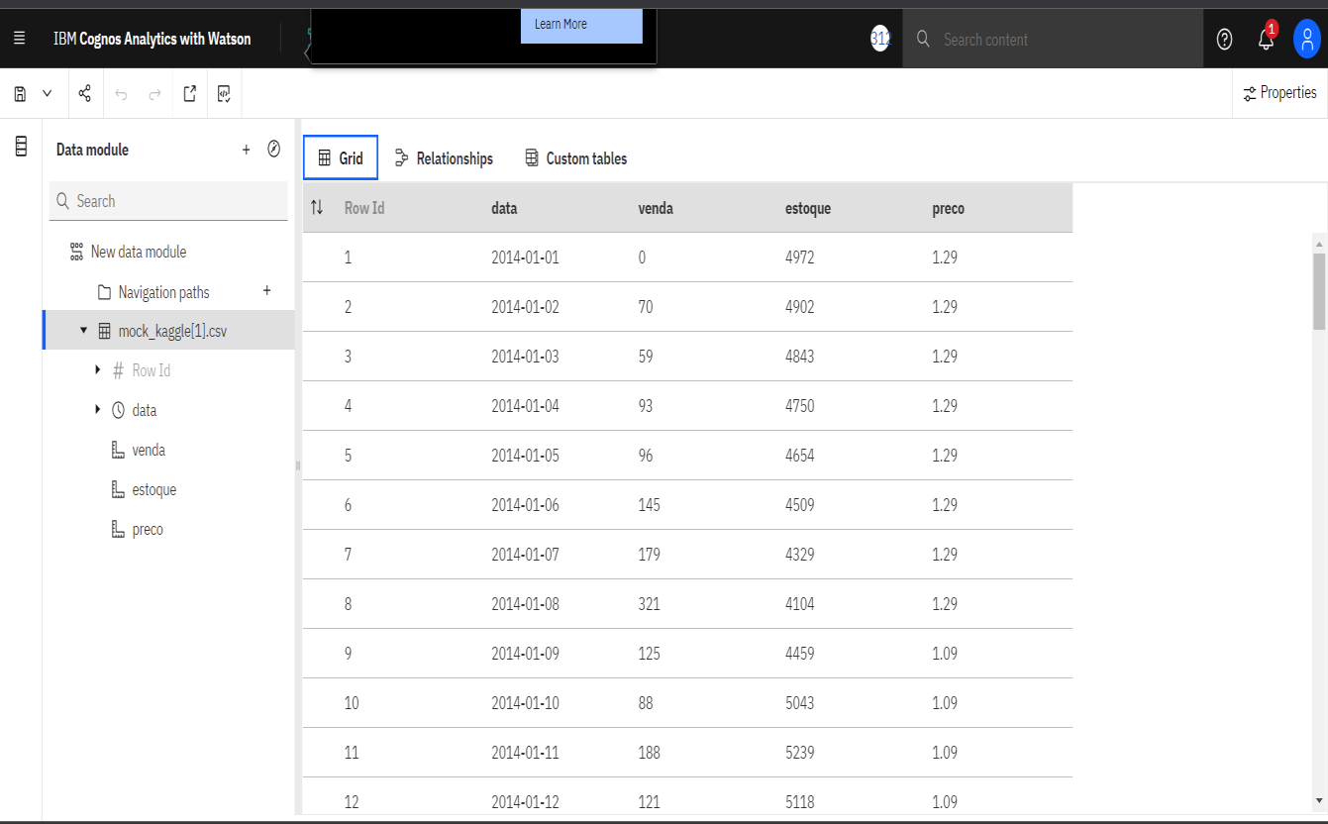

|  |  |
| --- | --- |
| **Team ID** | PNT2022TMID34348 |
| **Project Name** | Data analytics – Retail store stock inventory analytics |

Prepare the dataset: